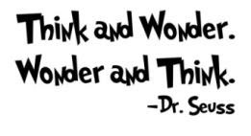
K-Note
Please return daily in the blue homework folder.

Week of January 13 - 17

Monday
- Our story for the week is The Big Ram. (Decodable Book #2)
- New sight words this week: not & big.

Tuesday
- Show-n-tell is Wednesday. Bring something that starts with LETTER B. The B treat is Brownies.

Wednesday
- Show-n-Tell is today.

Thursday

Friday
- There is an 11:30 am dismissal today.
- There is no school on Monday, January 20th.

This is what we are learning about this week in school.
In Writing, we are practicing the letter B. We are working on 2 sentence narrative writing.
In Reading, our story for the week is The Big Ram. (Decodable Book #2) .
In Phonemic Awareness, we are practicing: rhyming words, beginning and middle sounds, substituting a word to create a new word, adding suffixes at the end of a word to create a new word, and deleting a suffix from a word.
In Math, we are comparing objects length to linking cube sticks. We will begin weight measurement. We will compare objects using the words “heavier than” and “lighter than”. We will also use balance scales to determine if items that are heavier than, lighter than, or the same as.
In Social Studies, we are learning about Dr. Martin Luther King, Jr.
In Art, we made a capital B - Bear art and a lowercase b - butterfly art.
During story time, I’m reading books about bears.
Last week during coin store, the kids earned a movie and popcorn party. We will watch the movie on Friday, January 31st.

